# **Name: Abdurrahman Qureshi**

# **Roll No: 210451**

Practical No: 5

**1) Write a program to place Name, Age and mobile number linearly**

**(Vertical) on the display screen using Linear layout.**

**CODE:**

<?xml version="1.0" encoding="utf-8"?>  
<LinearLayout xmlns:android="http://schemas.android.com/apk/res/android"  
 xmlns:app="http://schemas.android.com/apk/res-auto"  
 xmlns:tools="http://schemas.android.com/tools"  
 android:layout_width="match_parent"  
 android:layout_height="match_parent"  
 tools:context=".HomePage"  
 android:orientation="vertical"  
 android:background="@color/black"  
  
 >  
 <LinearLayout  
 android:layout_width="match_parent"  
 android:layout_height="wrap_content"  
 android:background="@color/black"  
 android:layout_marginTop="280dp"  
 />  
 <TextView  
 android:layout_width="match_parent"  
 android:layout_height="wrap_content"  
 android:background="@color/black"  
 android:text="Name: qarq90"  
 android:textColor="@color/white"  
 android:textAlignment="center"  
 android:textSize="30dp" />  
 <TextView  
 android:layout_width="match_parent"  
 android:layout_height="wrap_content"  
 android:background="@color/black"  
 android:text="Age: 18"  
 android:textColor="@color/white"  
 android:textAlignment="center"  
 android:textSize="30dp" />  
 <TextView  
 android:layout_width="match_parent"  
 android:layout_height="wrap_content"  
 android:background="@color/black"  
 android:text="Phone Number: 8879662240"  
 android:textColor="@color/white"  
 android:textAlignment="center"  
 android:textSize="30dp" />  
</LinearLayout>

**OUTPUT:**

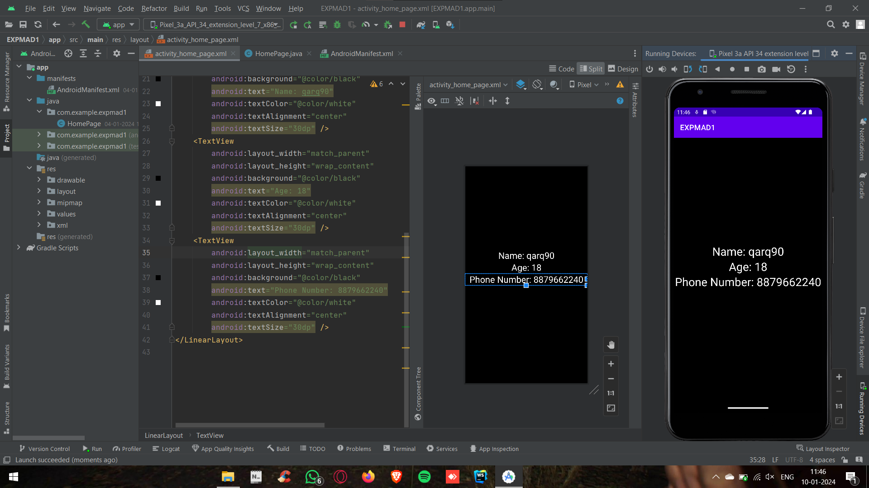

**2) Write a program to place Name, Age and mobile number centrally on the display screen using Absolute layout**

**CODE:**

<?xml version="1.0" encoding="utf-8"?>  
<LinearLayout xmlns:android="http://schemas.android.com/apk/res/android"  
 xmlns:app="http://schemas.android.com/apk/res-auto"  
 xmlns:tools="http://schemas.android.com/tools"  
 android:layout_width="match_parent"  
 android:layout_height="match_parent"  
 tools:context=".HomePage"  
 android:orientation="vertical"  
 android:background="@color/black"  
  
 >  
 <AbsoluteLayout  
 android:layout_width="match_parent"  
 android:layout_height="wrap_content"  
 android:background="@color/black"  
 />  
 <TextView  
 android:layout_width="wrap_content"  
 android:layout_height="wrap_content"  
 android:background="@color/black"  
 android:text="Name: qarq90"  
 android:textColor="@color/white"  
 android:translationY="300dp"  
 android:textSize="30dp" />  
 <TextView  
 android:layout_width="wrap_content"  
 android:layout_height="wrap_content"  
 android:background="@color/black"  
 android:text="Age: 18"  
 android:textColor="@color/white"  
 android:translationY="300dp"  
 android:textSize="30dp" />  
 <TextView  
 android:layout_width="wrap_content"  
 android:layout_height="wrap_content"  
 android:background="@color/black"  
 android:text="Phone Number: 8879662240"  
 android:textColor="@color/white"  
 android:translationY="300dp"  
 android:textSize="30dp" />  
</LinearLayout>

**OUTPUT:**

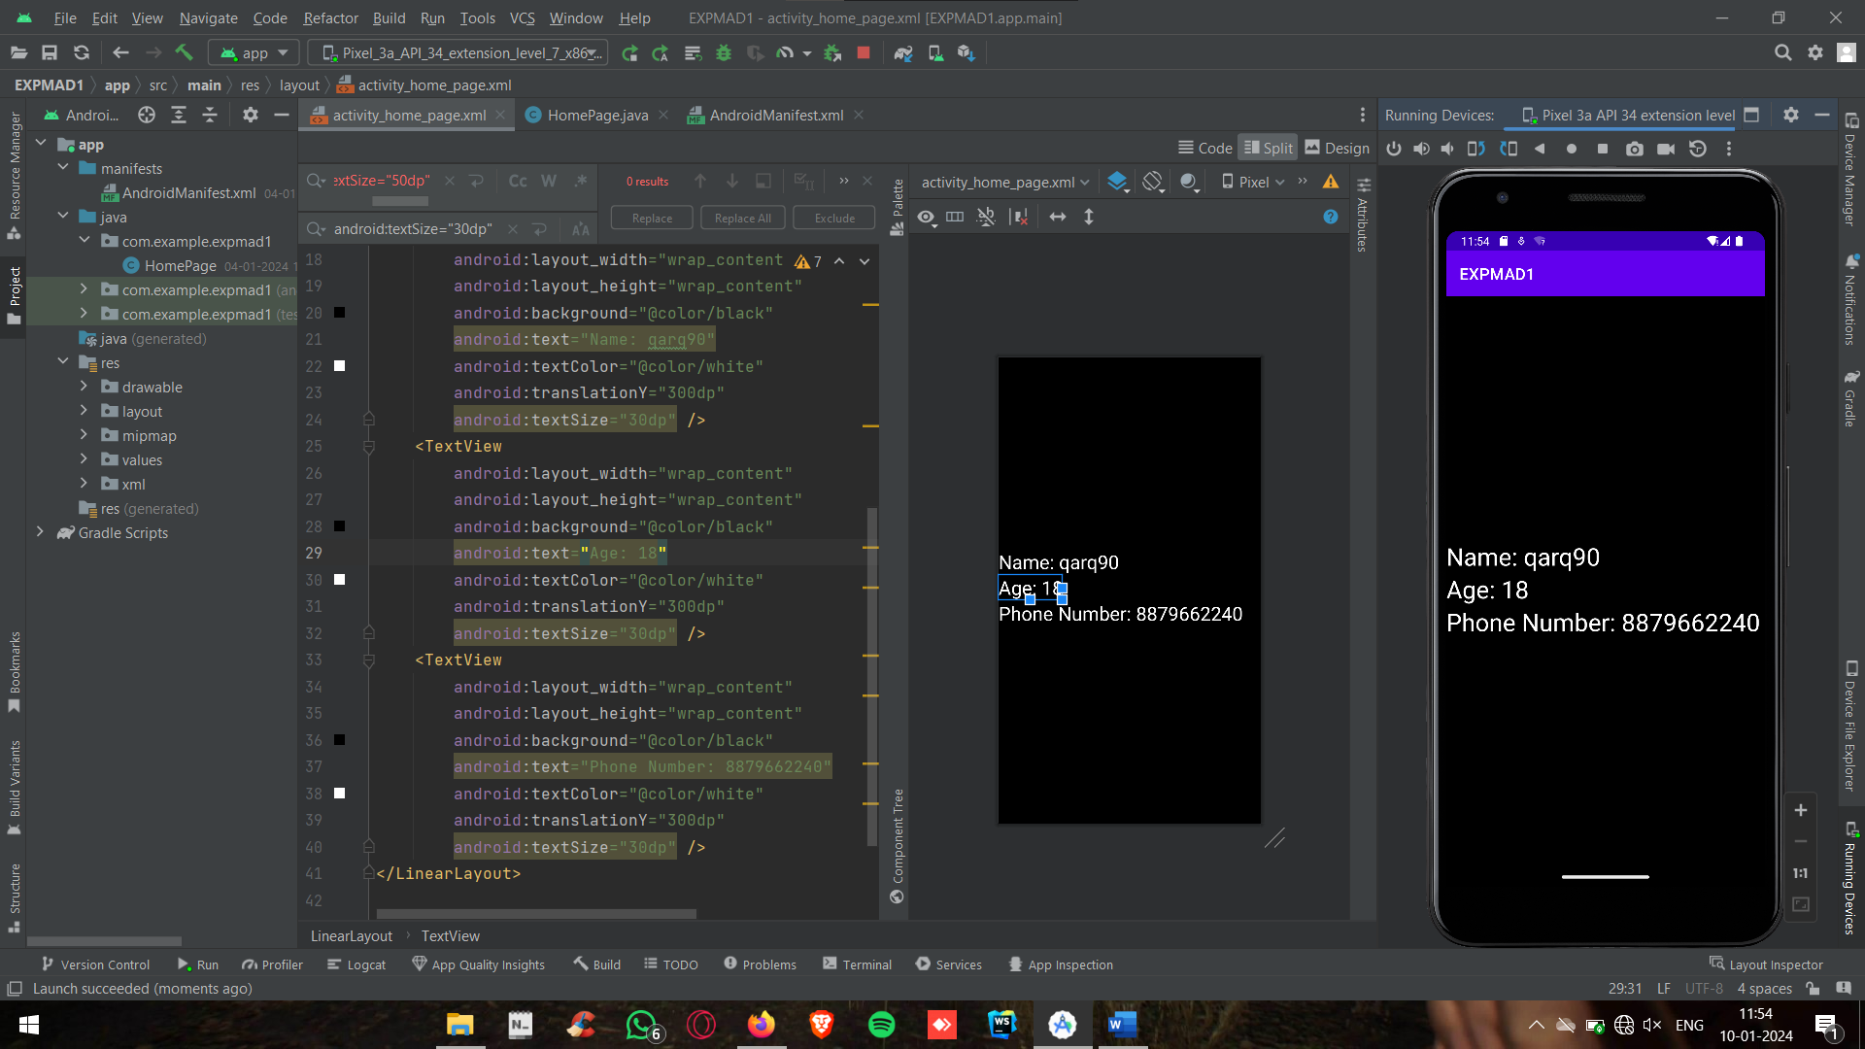

**3) Write a program to place Buttons horizontally via Linear Layout**

**CODE:**

<?xml version="1.0" encoding="utf-8"?>  
<LinearLayout xmlns:android="http://schemas.android.com/apk/res/android"  
 xmlns:app="http://schemas.android.com/apk/res-auto"  
 xmlns:tools="http://schemas.android.com/tools"  
 android:layout_width="match_parent"  
 android:layout_height="match_parent"  
 tools:context=".HomePage"  
 android:orientation="horizontal"  
 android:gravity="center"  
 android:background="@color/black"  
 >  
 <Button  
 android:layout_width="wrap_content"  
 android:layout_height="wrap_content"  
 android:text="New"  
 android:textSize="15dp"  
 />  
 <Button  
 android:layout_width="wrap_content"  
 android:layout_height="wrap_content"  
 android:text="Delete"  
 android:textSize="15dp"  
 />  
 <Button  
 android:layout_width="wrap_content"  
 android:layout_height="wrap_content"  
 android:text="Save"  
 android:textSize="15dp"  
 />  
 <Button  
 android:layout_width="wrap_content"  
 android:layout_height="wrap_content"  
 android:text="Update"  
 android:textSize="15dp"  
 />  
</LinearLayout>

**OUTPUT:**

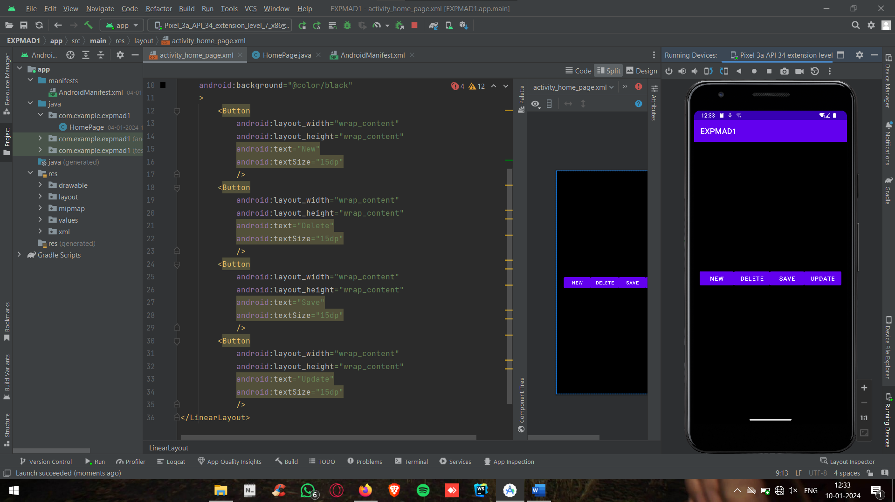

**4) Write a program to make a login form via Absolute Layout**

**CODE:**

<?xml version="1.0" encoding="utf-8"?>  
<AbsoluteLayout xmlns:android="http://schemas.android.com/apk/res/android"  
 xmlns:app="http://schemas.android.com/apk/res-auto"  
 xmlns:tools="http://schemas.android.com/tools"  
 android:layout_width="match_parent"  
 android:layout_height="match_parent"  
 tools:context=".HomePage"  
 android:orientation="horizontal"  
 android:gravity="center"  
 android:background="@color/black"  
 >  
 <TextView  
 android:layout_width="wrap_content"  
 android:layout_height="wrap_content"  
 android:text="Login Form"  
 android:translationX="120"  
 android:translationY="200"  
 android:textColor="@color/white"  
 android:textSize="30dp"  
 />  
 <TextView  
 android:layout_width="wrap_content"  
 android:layout_height="wrap_content"  
 android:text="Email"  
 android:translationX="30"  
 android:translationY="280"  
 android:textColor="@color/white"  
 android:textSize="30dp"  
 />  
 <EditText  
 android:layout_width="220"  
 android:layout_height="wrap_content"  
 android:translationX="180"  
 android:translationY="280"  
 android:textColor="@color/black"  
 android:textSize="30dp"  
 android:background="@color/white"  
 />  
 <TextView  
 android:layout_width="wrap_content"  
 android:layout_height="wrap_content"  
 android:text="Password"  
 android:translationX="30"  
 android:translationY="350"  
 android:textColor="@color/white"  
 android:textSize="30dp"  
 />  
 <EditText  
 android:layout_width="220"  
 android:layout_height="wrap_content"  
 android:translationX="180"  
 android:translationY="350"  
 android:textColor="@color/black"  
 android:textSize="30dp"  
 android:background="@color/white"  
 />  
</AbsoluteLayout>

**OUTPUT:**

